Requirements
Tailwind Traders is planning on making some significant changes to their governance solution. They have asked for your assistance with recommendations and questions. Here are the specific requirements.
- Cost and accounting. Tailwind Traders has two main business units that handle Apparel and Sporting Goods. Each of the business units consist of three departments: Product Development, Marketing, and Sales. Each business unit and subunit will be responsible for tracking their Azure spend. At the same time, the Enterprise IT team will be responsible for providing company-wide Azure cost reporting.
- New development project. The company has a new development project for customer feedback. The CFO wants to ensure all costs associated with the project are captured. For the testing phase, workloads should be hosted on lower cost virtual machines. The virtual machines should be named to indicate they are part of the project. Any instances of non-compliance with resource consistency rules should be automatically identified.

Copilot prompt reference: https://copilot.microsoft.com/shares/Y3oo5BPg6QP6kNFhDepqR

Solution Approaches
Tailwind Traders needs both granular cost tracking (per department) and enterprise-wide reporting. Azure provides two main constructs:
- Management Groups: Logical containers for organizing subscriptions and applying policies.
- Subscriptions: Boundaries for billing, resource management, and access control.
Option 1: Department-Level Subscriptions
- Each department (Product Development, Marketing, Sales) gets its own subscription.
- Subscriptions are grouped under their respective Business Unit Management Group (Apparel, Sporting Goods).
- Enterprise IT has a Root Management Group for consolidated reporting.
Hierarchy Example (Created using Lucidapp):
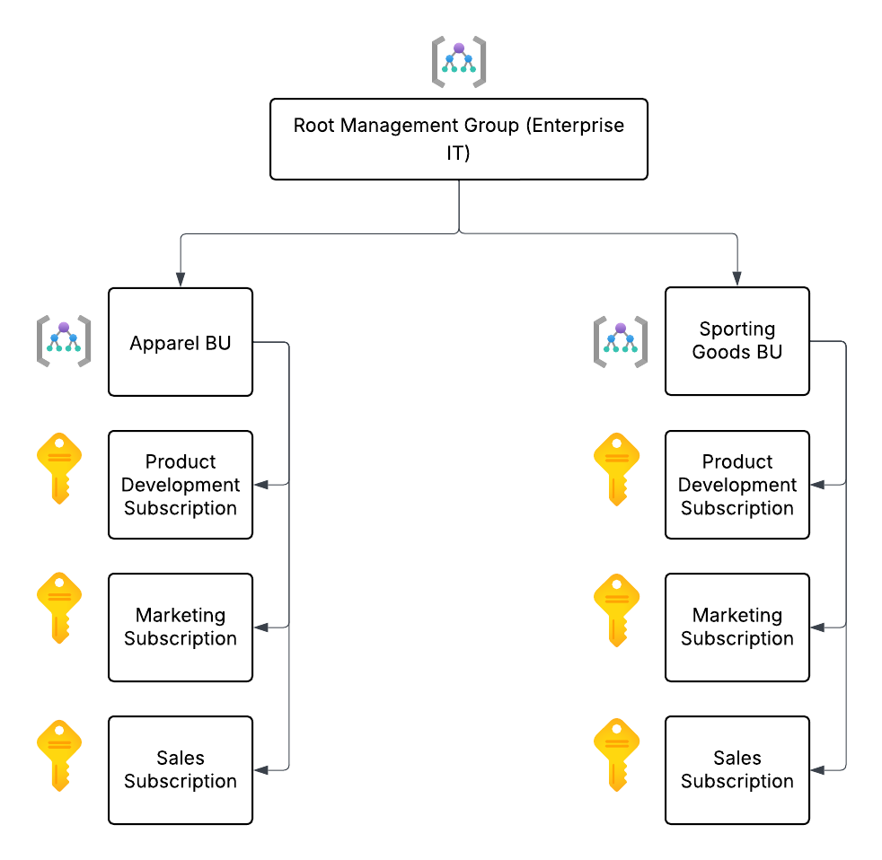

Pros:
- Clear cost segregation per department.
- Easy to apply policies at BU or enterprise level.
- Flexible scaling for future departments.
Cons:
- Higher subscription count → more administrative overhead.
Option 2: Business Unit-Level Subscriptions with Departmental Tagging
- One subscription per business unit (Apparel, Sporting Goods).
- Departments tracked via resource tagging (e.g., Department=Marketing).
- Management Groups still organize subscriptions by BU.

Hierarchy Example (Created using Lucidapp):
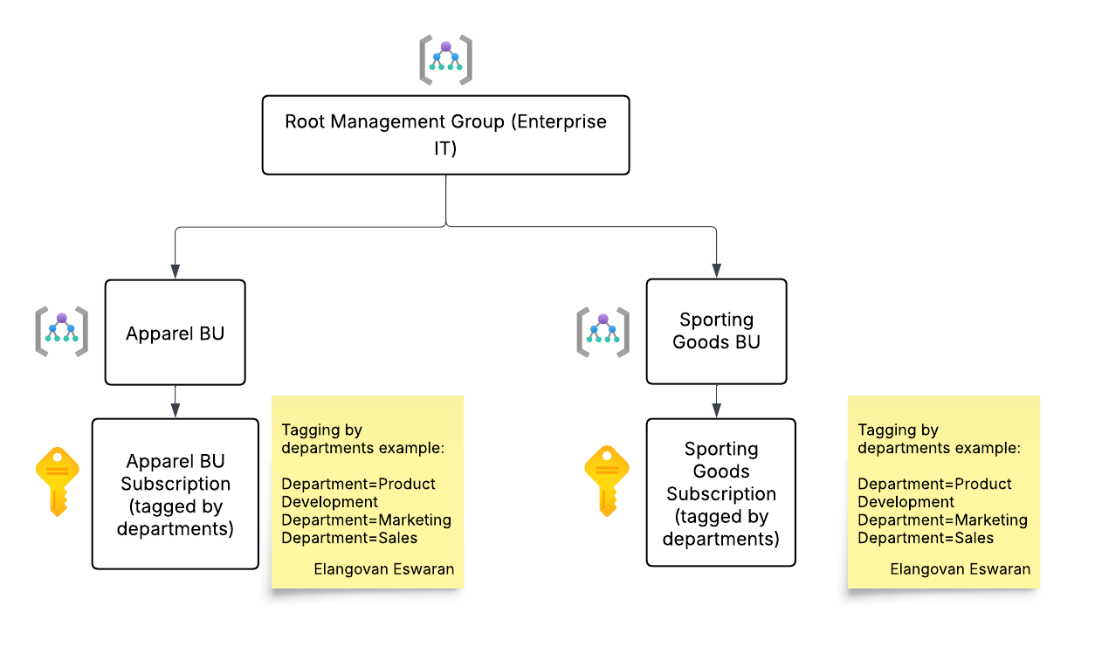
Pros:
- Fewer subscriptions → simpler administration.
- Tags allow flexible cost reporting by department.
Cons:
- Requires strict tagging discipline.
- Risk of mis-tagged resources affecting reporting accuracy.
Best Fit
- Option 1 is best if Tailwind Traders prioritizes strict isolation and accountability per department.
- Option 2 is best if they want simpler subscription management but are confident in enforcing tagging compliance.
New Development Project
Tracking Costs
Tailwind Traders can track project costs using:
- Dedicated Subscription for the project → isolates costs completely.
- Resource Group within an existing subscription → scoped cost tracking.
- Tagging Strategy (e.g., Project=CustomerFeedback) → enables filtering in cost reports.
Best Fit: A dedicated resource group with mandatory project tags inside the relevant subscription. This balances isolation with manageability.
Ensuring Compliance (VM Sizing & Naming)
Approach 1: Azure Policy
- Define policies to enforce:
  - Allowed VM SKUs (e.g., only lower-cost SKUs like B-series).
  - Naming conventions (e.g., must start with CFB- for Customer Feedback Project).
- Non-compliant resources are flagged or denied at deployment.
Approach 2: Azure Blueprints
- Create a blueprint for the project environment:
  - Includes policies for VM size and naming.
  - Ensures consistent deployment across environments.
Final Decision
- Primary Enforcement: Use Azure Policy for VM size and naming compliance. It provides real-time enforcement and reporting.
- Cost Tracking: Use mandatory tagging (Project=CustomerFeedback) combined with a dedicated resource group. This ensures costs are captured without needing a separate subscription.

